Request for Project Evaluation (RFPE) - Geoweb® Slope Protection System

To ensure we are offering a suitable design suggestion for your project please complete and return this
RFPE form with as much detail as possible. Once completed we can supply you with a calculation and proposal.

Q-Reference (Internal use only): Click or tap here to enter text.

Date: Click here to select date

Project Name: Click or tap here to enter text.

Product Location – postcode / city: Click or tap here to enter text.

Tender: Yes ☐ / No ☐

Approximate start of works: Click or tap here to enter text.

Approximate date material required: Click or tap here to enter text.

Estimated Geoweb® area (Length x width): Click or tap here to enter text.

Describe problem to be solved by Geoweb® system; including any site restrictions such as access and please provide a sketch or cross section and plans when available: Click or tap here to enter text.

Please Note:
The accuracy of preliminary designs/ evaluations based on RFPEs depends on the quality of the dates provided. Specific values/ information which cannot be provided reduce the quality and reliability of preliminary designs since comparable values have to be assumed. Final designs should always be based on proper soil investigations and detailed load parameters.

Disclaimer / Limitations of use:
Evaluations/ preliminary designs are copyrighted and specifically based upon the unique characteristics of Presto Product’s Patented Geoweb® material. Evaluations will be prepared solely for the requestor. Use of any part of evaluations/ preliminary designs with any materials not manufactured by Presto Products is strictly prohibited and shall make evaluations / preliminary designs invalid. The purpose of evaluations / preliminary designs is to provide a potential use of Geoweb® products and does not represent an actual design to be used for construction or any other purposes. A final design shall be prepared by a licensed professional engineer based on actual field conditions.
Embankment Type:

Cut embankment ☐ Fill embankment ☐ Shoreline revetment ☐

Landfill slope ☐ Natural slope ☐ Natural channel slope ☐

Other: Click or tap here to enter text.

Is the embankment covered by a Geomembrane or Liner? Yes ☐ / No ☐

Slope dimensions:

Slope angle (ᐤ) Click or tap here to enter text. or (H:V) Click or tap here to enter text.

Vertical height (V)(m) Click or tap here to enter text.

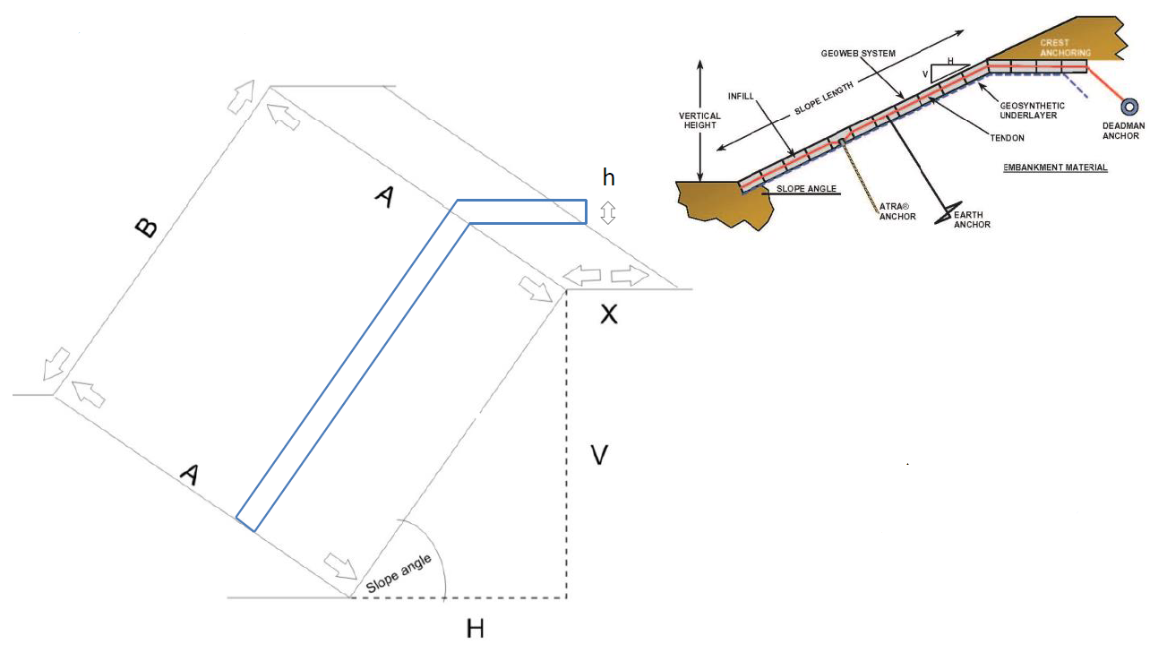

A (m)= Click or tap here to enter text.

B (m)=Click or tap here to enter text.
X = is additional space for anchoring on the crest of the slope available?

Yes ☐ (Click or tap here to enter text. m) No ☐

Requested layer thickness / depth of Geoweb requested (mm): Click or tap here to enter text.

Existing Slope:

Kind of soil (description): Click or tap here to enter text.

Specific weight (kN/m3): Click or tap here to enter text.

Angle of internal friction (ᐤ): Click or tap here to enter text.

Cohesion (kN/m2): Click or tap here to enter text.

Filling Material:

Kind of filling materials (description): Click or tap here to enter text.

Specific weight (Kn/m3): Click or tap here to enter text.

Angle of internal friction (ᐤ): Click or tap here to enter text.

Cohesion (Kn/m2): Click or tap here to enter text.

Additional filling material (on top of Geoweb®):

Kind of filling material (description):Click or tap here to enter text.

Specific weight (Kn/m3): Click or tap here to enter text.

Angle of internal friction (ᐤ): Click or tap here to enter text.

Cohesion (Kn/m2): Click or tap here to enter text.

Height above Geoweb® (mm): Click or tap here to enter text.

Hydraulic Conditions:

Surface sheet Runoff ☐ Wave Action ☐ Concentrated Runoff ☐

Ice Action ☐ Ground Water Seepage ☐ Other: Click or tap here to enter text.

Action required:

Cost estimation ☐ Quotation ☐

Preliminary design/ Calculation ☐ (needed by): Click or tap here to enter text.

